Intial Execution of JPS comment:

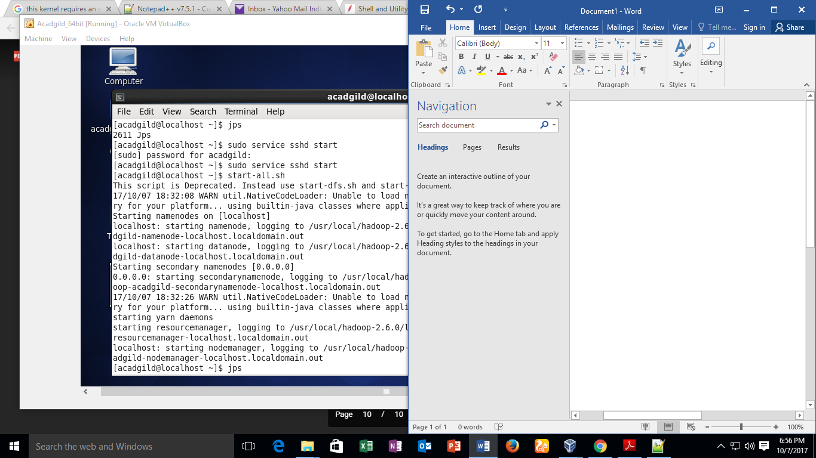

Start the HistoryServer & Start the Pig in HDFS mode:

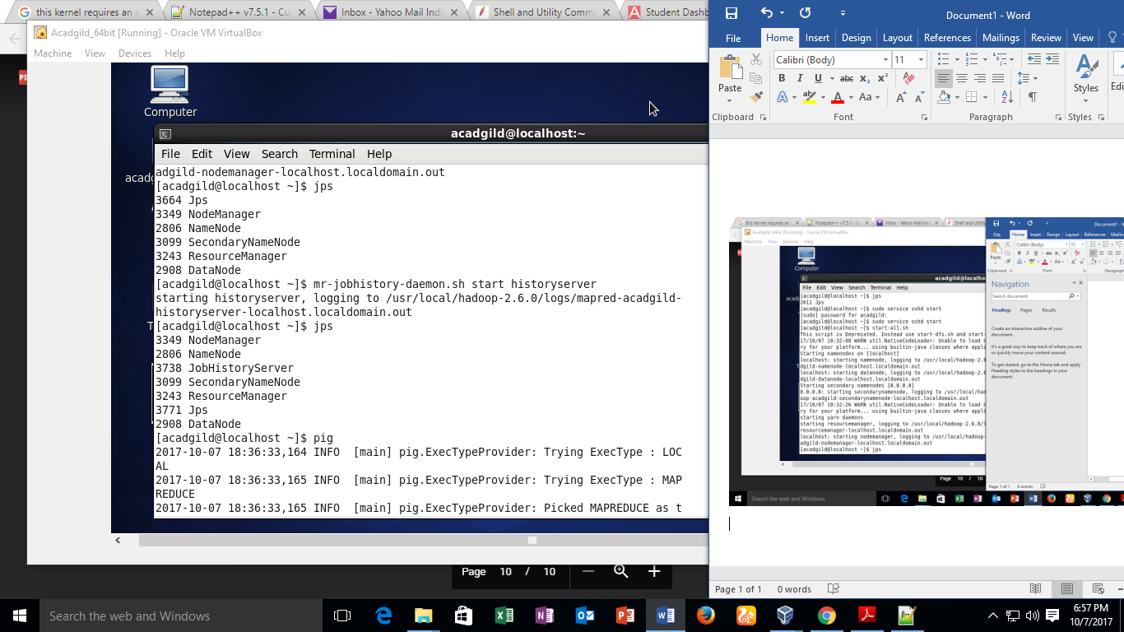

Coming out of Pig mode, Start mysqldb and start the hive:

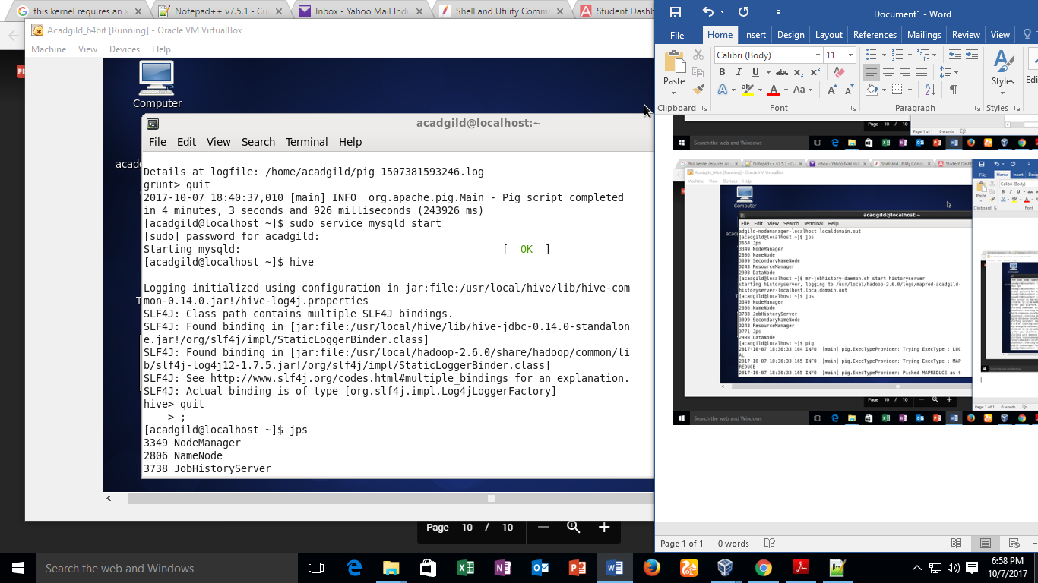

Start Hbase:

